Dear Student:

Welcome to the amazing and unique Triple Play class where the curriculum of Honors Human Anatomy & Physiology, AP Biology, and Post AP Advanced DNA & Genetics Research will be covered while meeting one block per day during both the fall and spring semester.

This fast paced and exciting class will require students to be intrinsically motivated and enthusiastically willing to independently keep up with classwork. Be reminded that AP Bio and ADG are both college level classes in content and context; they should be approached accordingly.

Attached you will find a packet of terminology and introductory concepts for you to review this summer (Unit 1 in Anatomy/Physiology). There are a number of easily accessible, bona fide websites that can assist your progress. I regularly check my email (joanne.jezequel@cobbk12.org) if you need to ask me any questions. I will go over ALL of this material when we start school in the fall, but you should be ready to hit the ground running. There will be a quiz on anatomical terminology (Name that Body Part!), within the first few days, and you should expect a Unit 1 test this material after I have had a chance to be sure you all are proficient and confident.

In addition to reviewing this packet, students should also access the course syllabus prior to the first day of school (click on the “Triple Play Syllabus” tab on my weebly website, drjezequel.weebly.com). Please print just the LAST page; sign it/obtain parent or guardian signature, and bring to class the first day of school.

Students are also asked to click on the “Supplies” link and purchase necessary classroom items prior to the start of school. Please note: any student who is able to donate tissues, liquid hand soap, liquid dish detergent (like “Dawn”), spray cleaner (like “409”), and Lysol wipes is asked to do so. These items will be for shared classroom use, and MUCH appreciated.

Best wishes for a terrific summer break! Be sure to re-charge, stay safe, appreciate your friends and family, and note the beauty in the world around you.

#science
#TriplePlay

~Dr. Jezequel

Dr. Jezequel
Anatomical Terms

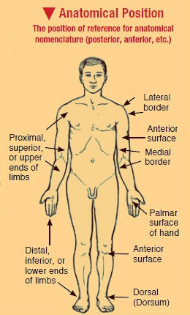
what is the difference between “anatomy” and “physiology”?

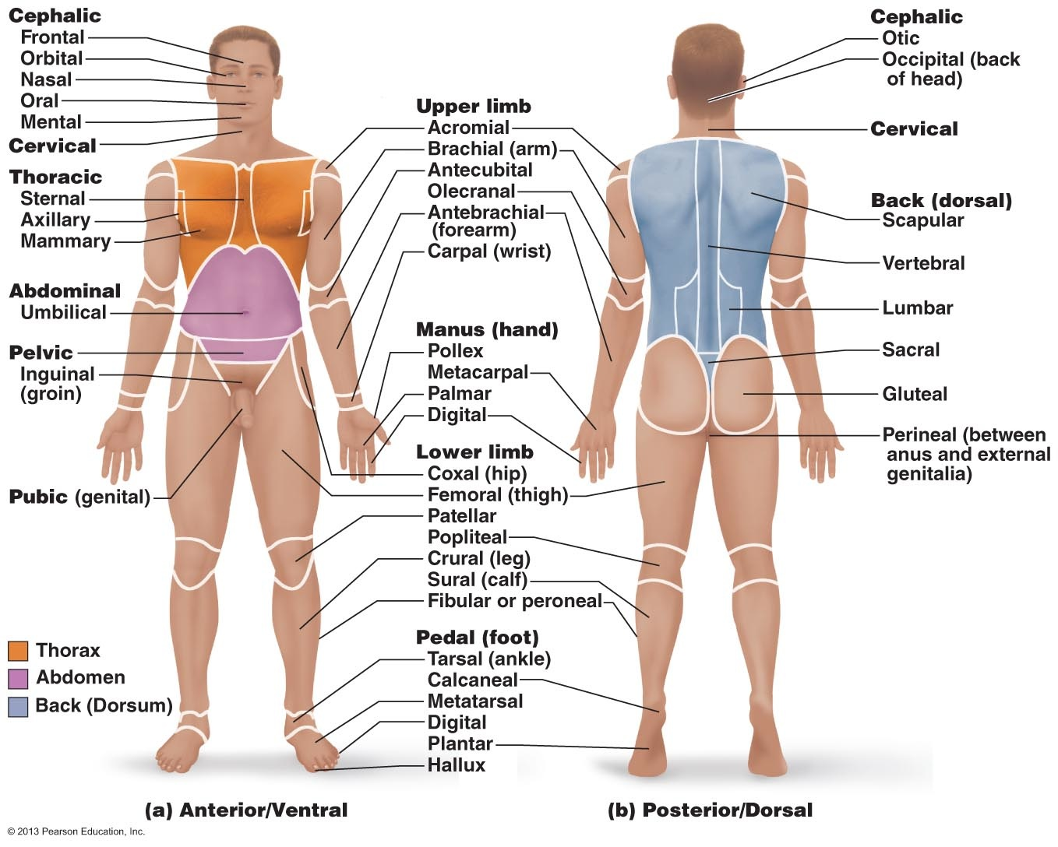

Dr. Jezequel
Anatomical Directional Terms

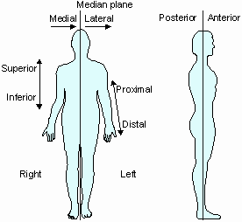

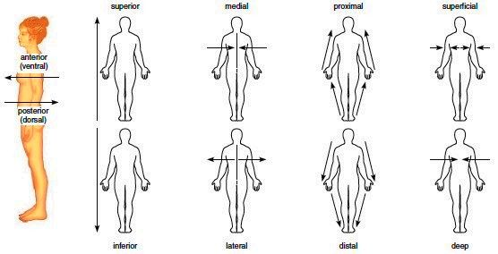

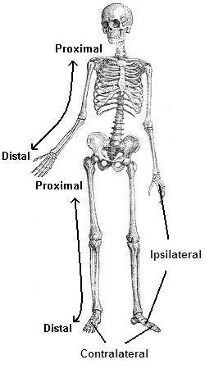

Ipsilateral: Same side as reference point
Contralateral: Opposite side of reference point

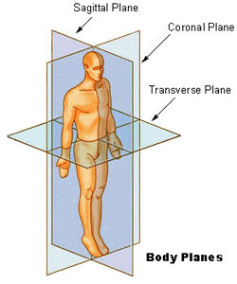

Dr. Jezequel
Practice Sheets

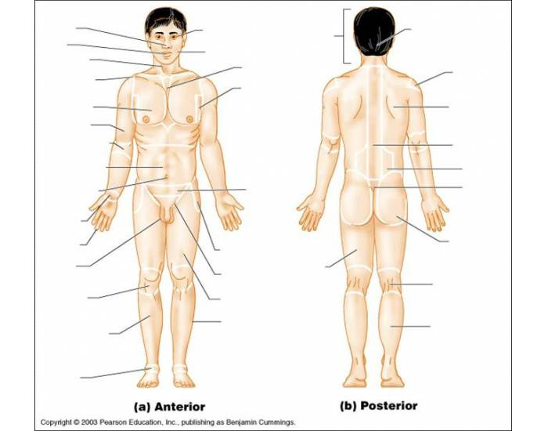

Dr. Jezequel

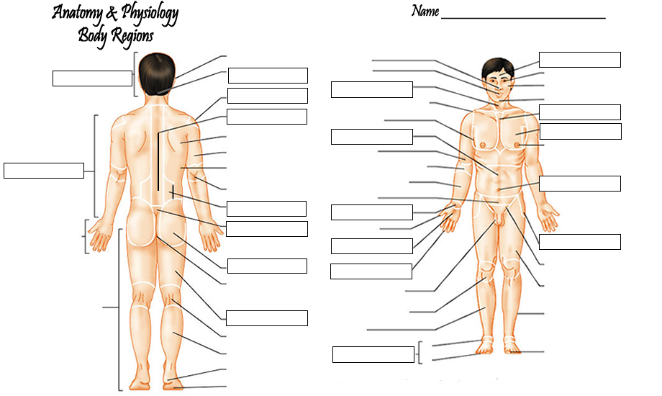

Abdominal Quadrants/Regions

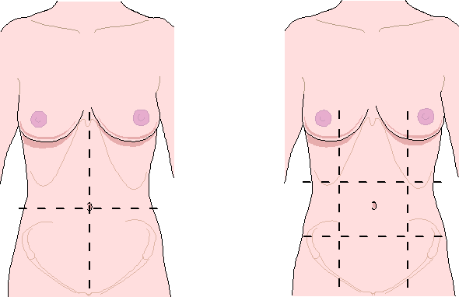

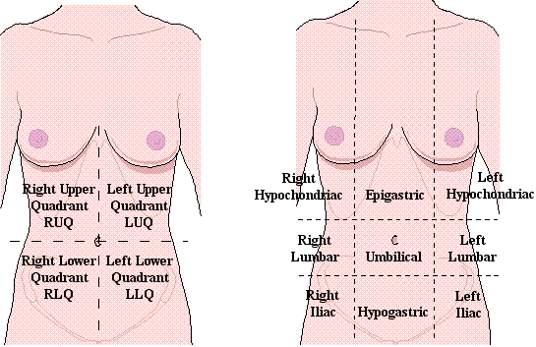

What is the most significant structure located in the:

RUQ:

LUQ:

RLQ:

LLQ:

Atoms MoleculesCells Tissues Organs Organ System Organism

Intracellular Fluid (ICF) vs. Extracellular Fluid (ECF)

Mediastinum

Body Cavities:

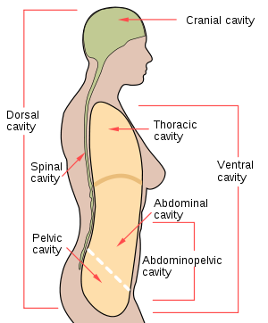

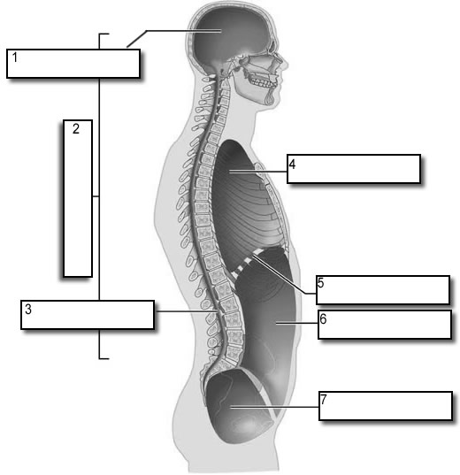

Serous Membranes:
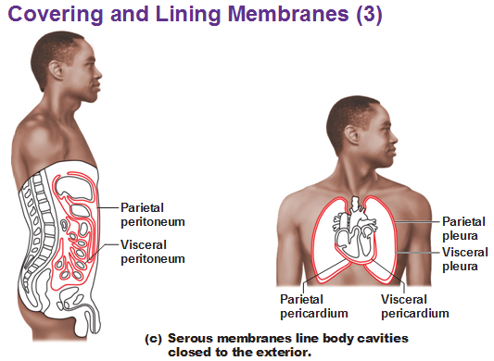

What is the difference between the visceral and parietal layer of a serous membrane?

What is located between the visceral and parietal layer of a serous membrane? (What is its purpose?)

Meninges: superficial deep?

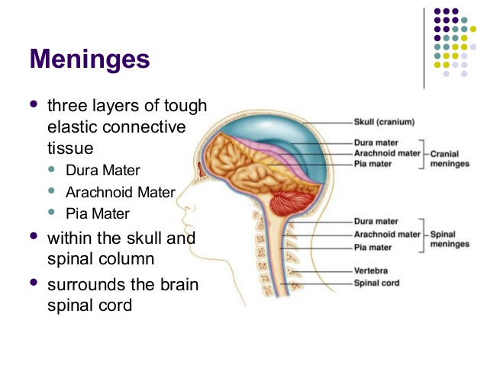

PATIENT HISTORY:

CC = chief complaint (what brings you here?)

OPQRST

OPQRST is used for the history taking section of patient assessments.
O | Onset  - What was the patient doing when the signs and symptoms first occurred? Was the onset sudden or gradual?
P | Provocation / Palliation  - Is there anything that makes the symptom better or worse?
Q | Quality  - Description of what the patient is feeling. For example, the pain can be described as dull, sharp, crushing, aching, tearing, throbbing, etc.
R | Region / Radiation  - Where is the pain located and does it move to another part of the body?
S | Severity  - How severe is the symptom based on a scale of 1 to 10?
T | Time  - When did the signs and symptoms first occur?
HITS:

Previous: Hospitalizations?
Illnesses?
Traumas?
Surgeries?

ROS (Review of Systems) What is this?

Examination
(What does each term mean? What special equipment might be necessary for each part of the physical exam?)

- Inspect

- Palpate

- Auscultate

- Percuss

Special Studies? (Lab work? Diagnostic Imaging? Other?)

HUMAN BODY SYSTEMS:

- How many human body systems? __________
- Complete the following chart:

Name of System | Major Organs &/or Parts | Major Function

Diagnostic Imaging:
- Briefly describe/define
- Utilized for? (Hard tissue? Soft tissue? Pathology?)

X-Ray:
1.

2.

MRI (Magnetic Resonance Imaging)

1.

2.

CT Scan (Computerized Axial Tomography):

1.

2.

Ultrasound (Sonogram)

1.

2.

Sign vs Symptom: What is the difference?

List 3 signs:

List 3 symptoms:

What are vital signs? (list; provide normal adult values for each)

Define homeostasis:

What is the difference between a negative and a positive feedback system?

Provide examples of both negative and positive feedback systems:

Provide description, signs & symptoms for:

- Mononucleosis

- Hiatal Hernia

Overall Review of Unit 1:

*anatomy vs. physiology (be able to identify various studies in each specialty area)
*sign vs. symptom (be able to identify examples of each)
*feedback systems (positive vs. negative, recognize examples of each, receptors, control center, stimulation, effector)
*homeostasis: what is it? What controls it? Which systems exert majority influence?
*percuss, palpate, inspect, auscultate (what do these mean? Is there special equipment required?)
*basic life processes
*planes
*ICF vs. ECF
*regions vs. quadrants (names, what is where?)
*directional terms
*mediastinum: what is it? Where is it? What is located there?
*pleural layers
*meningeal layers
*diagnostic imaging
*medical terminology (parts)

